Dual LED Flasher  
Test Build Instructions  
  
Parts List:

Breadboard, with rails.  
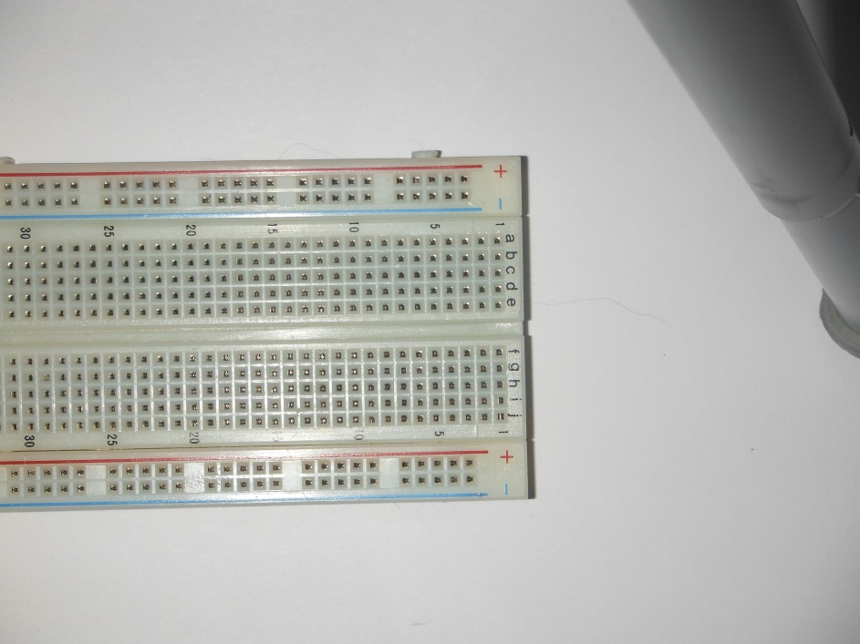  
  
2x 470 Ohm (Yellow, Purple, Brown) Resistor   
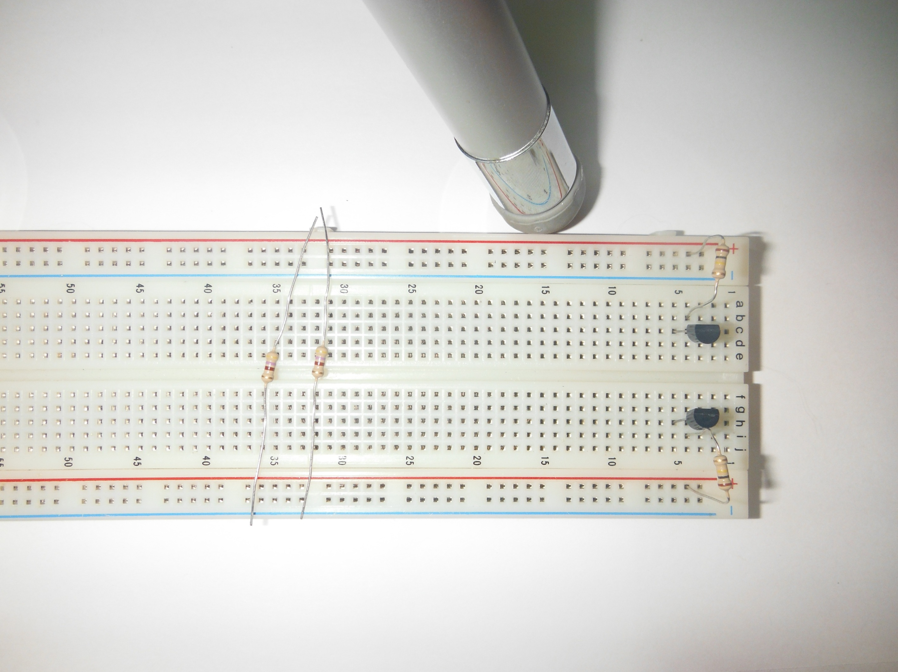

2x 100k Ohm (Brown, Black, Yellow) Resistor  
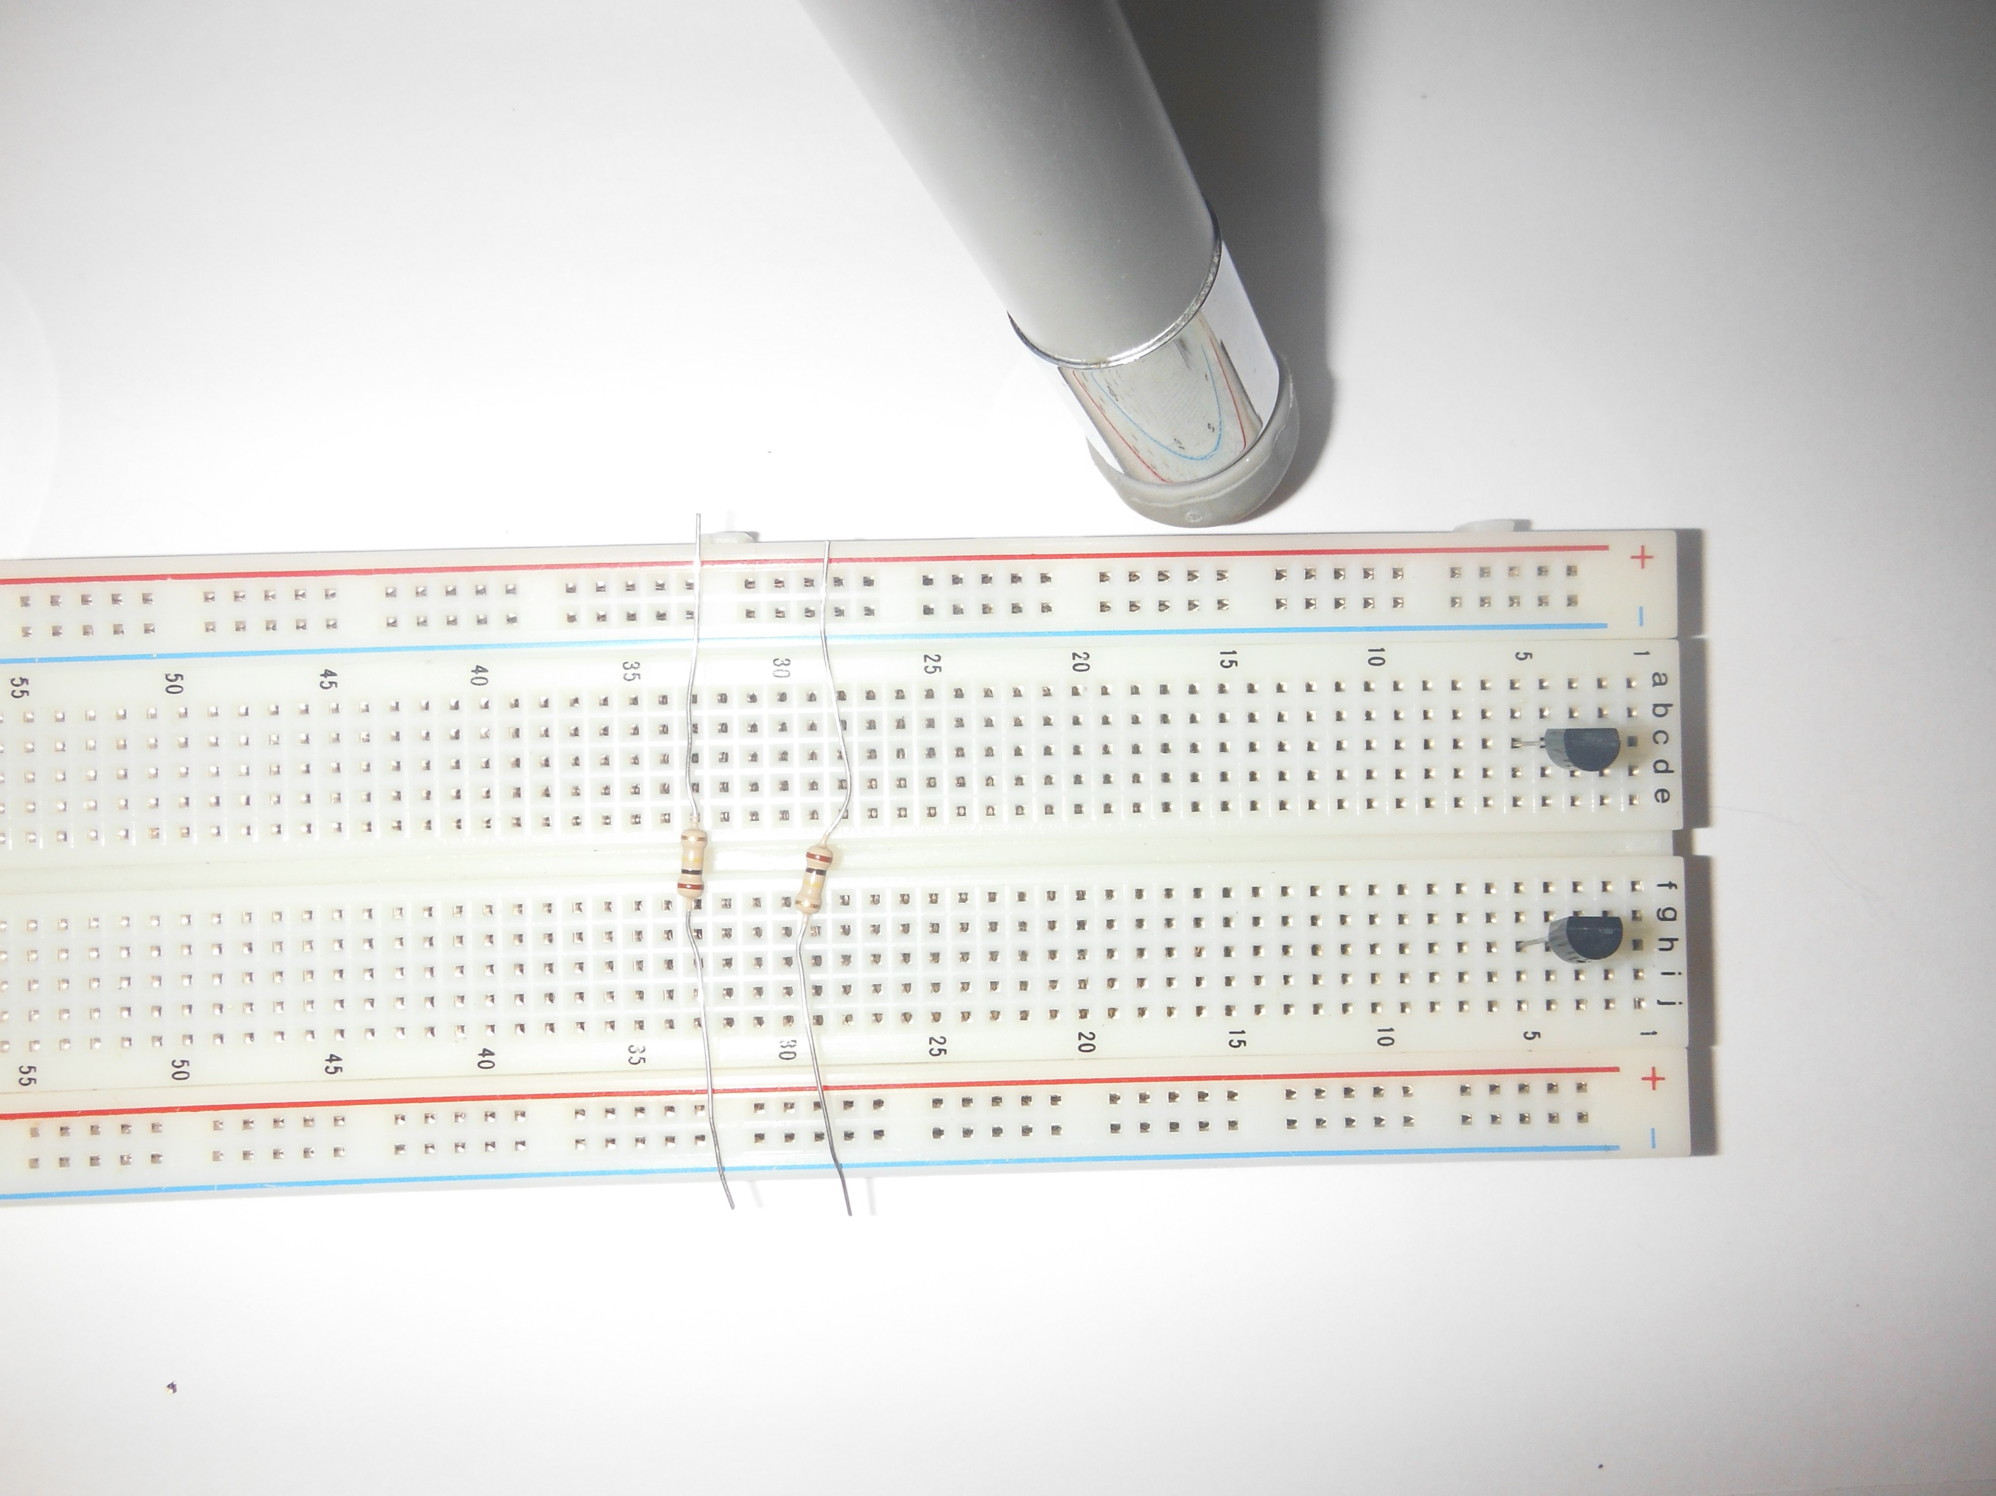  
  
2x Light Emitting Diode (LED)  
Polarized, Long Leg Positive  
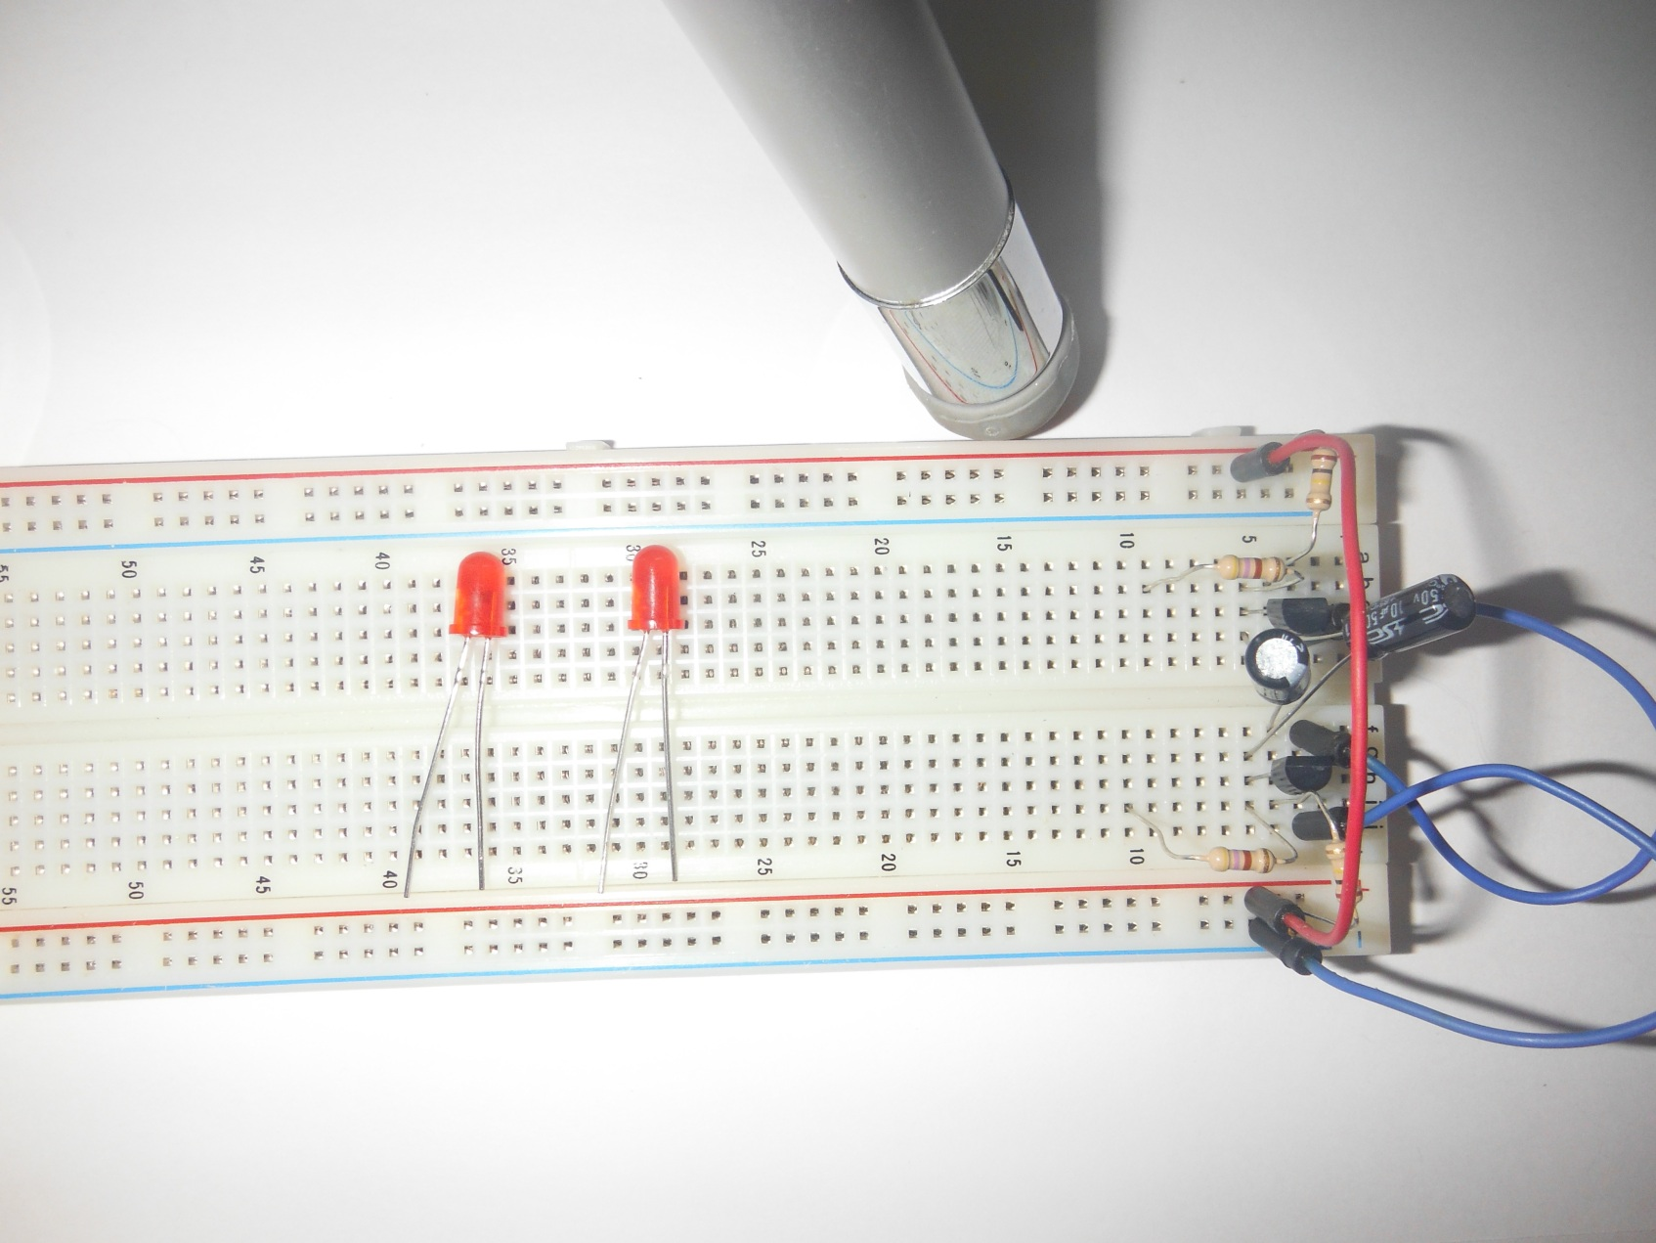

2x Electrolytic Capacitor  
Polarized, Long Leg Positive  
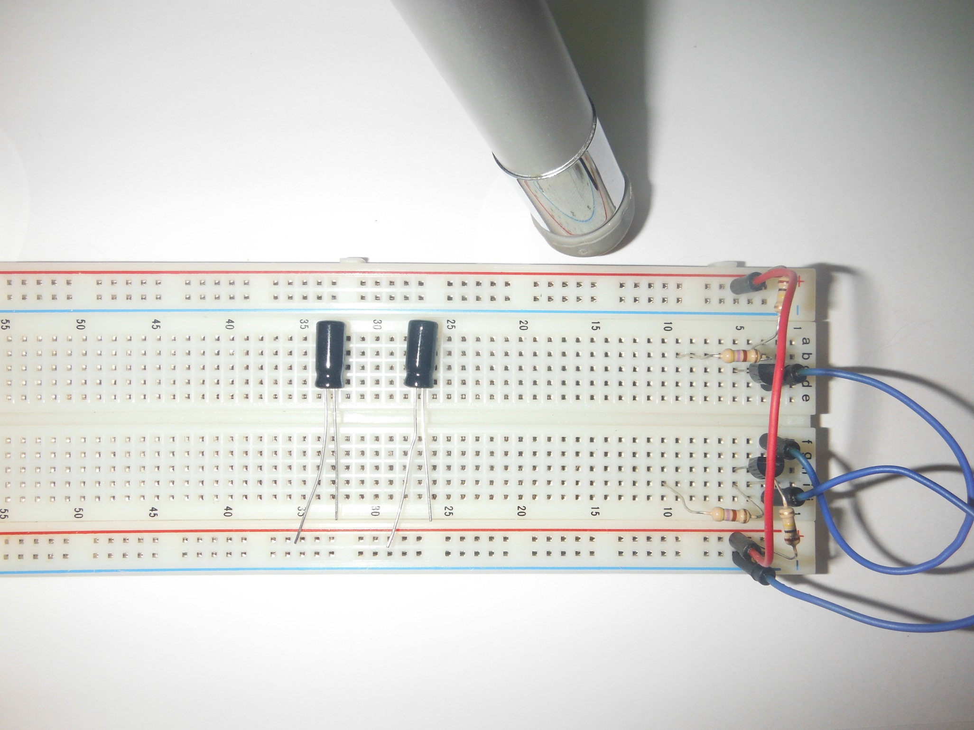

2x 2n3094 Transistors  
Polarized, Round End Up  
Collector (C), Base (B), Emitter (E)  
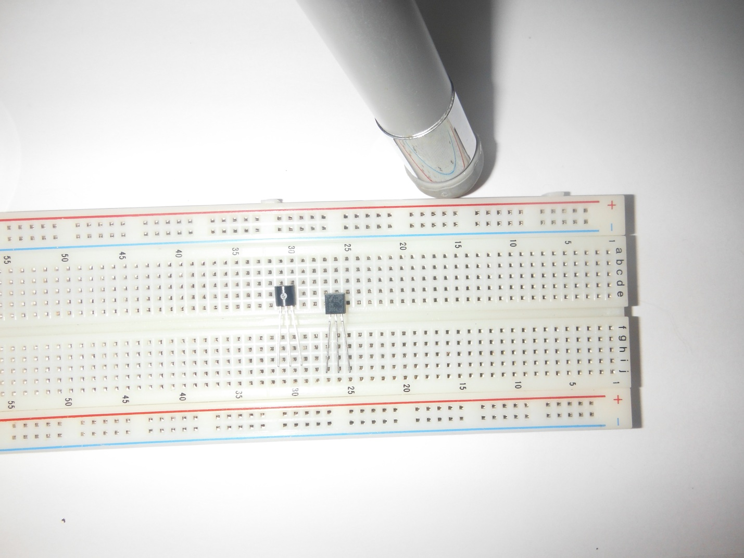

1) Position breadboard with numbers starting on the right.  
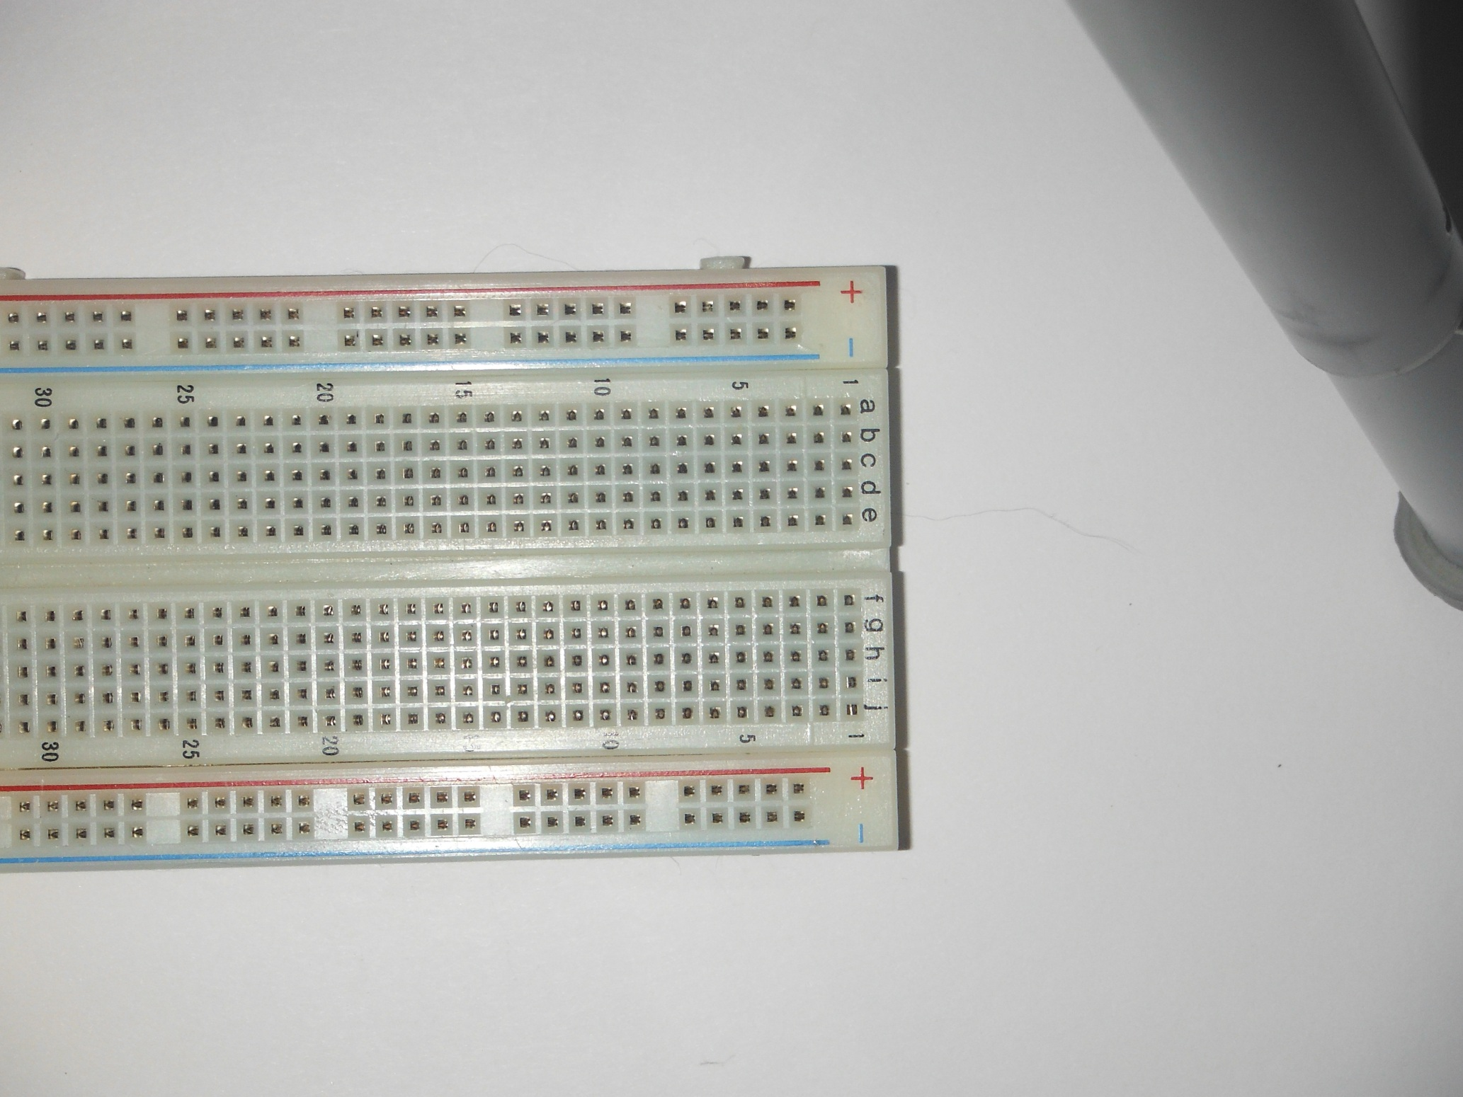  
  
2) Insert two transistors, flat side facing up (CBE), C in column 5, E in Column 3.  
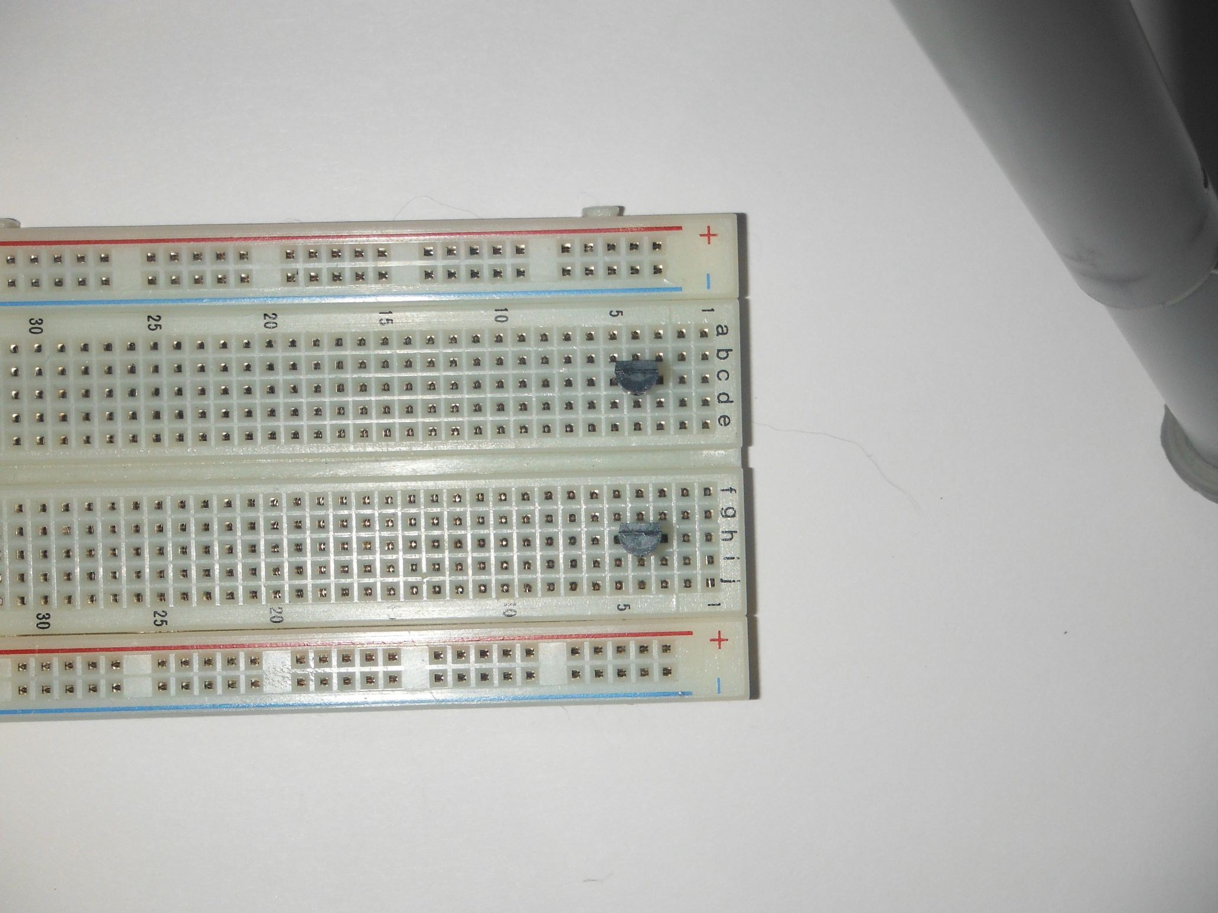

3) Insert 100K Ohm Resistor, from Base (B) of each transistor (Column 4), to Positive (Red) Rail  
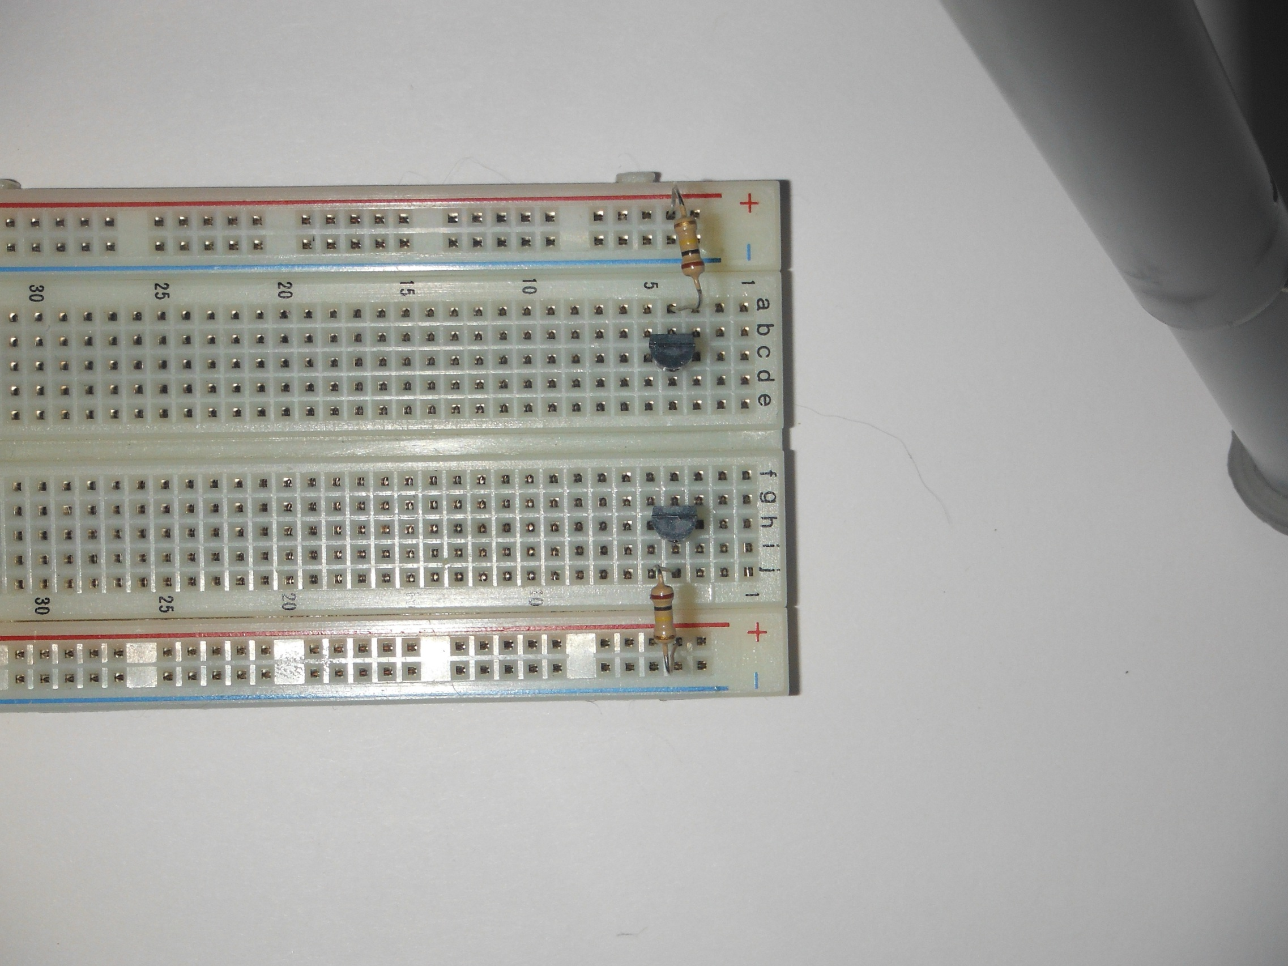

4) Insert 470 Ohm Resistor, From Collector (C) of each transistor (Column 5), to Colum 10.  
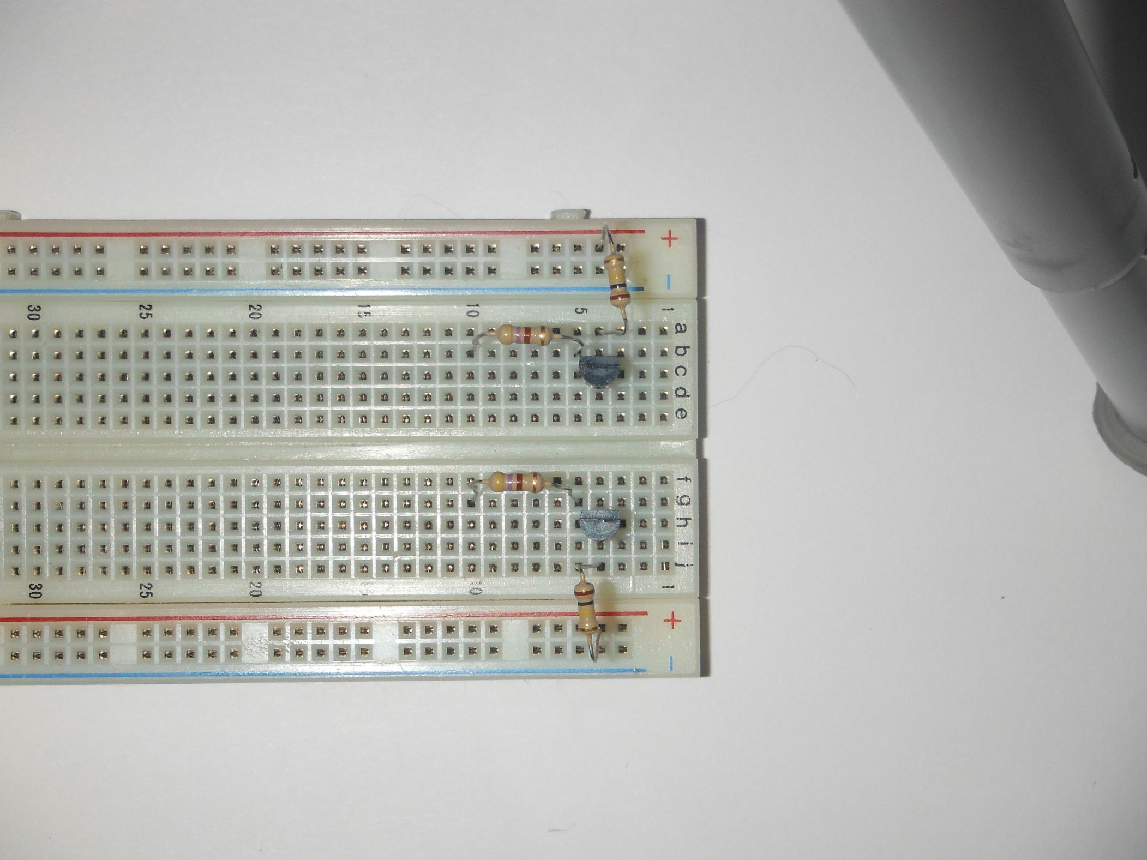

5) Insert LEDs from Column 10 to Positive Rail (Red), Long Leg.  
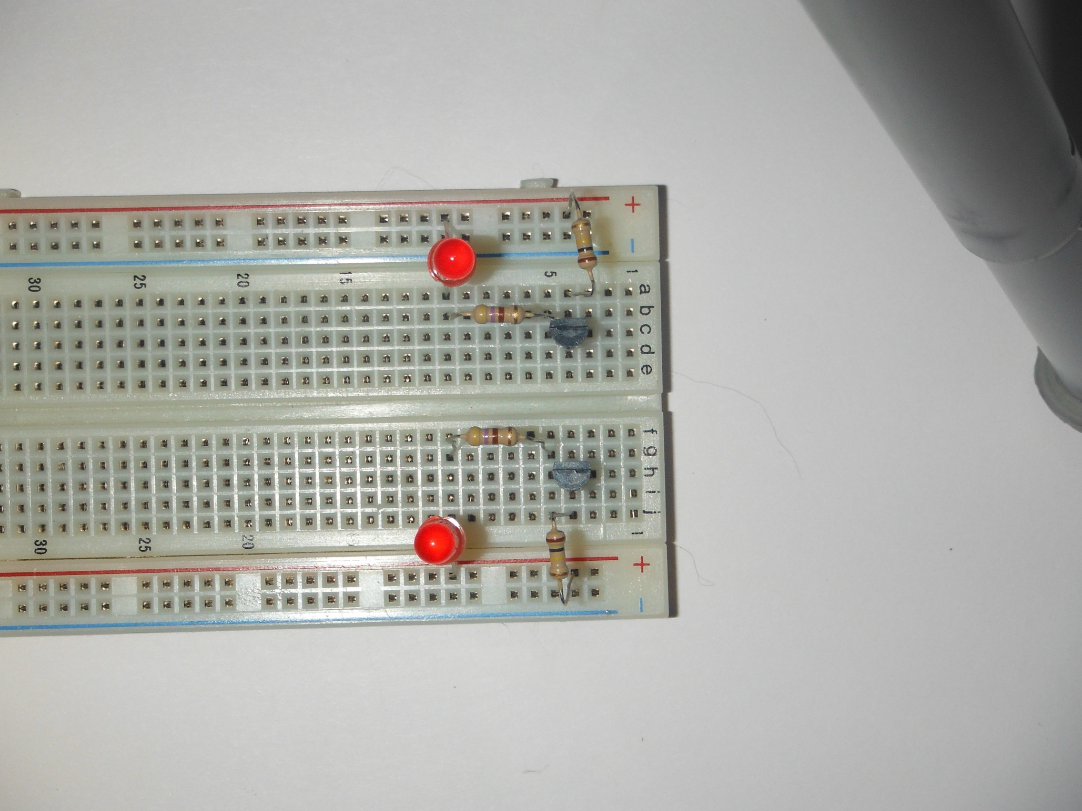  
  
6) Insert capacitor, Long Leg at upper transistor Collector (C) Column 5, Short Leg at lower transistor Base (B) Column 4.  
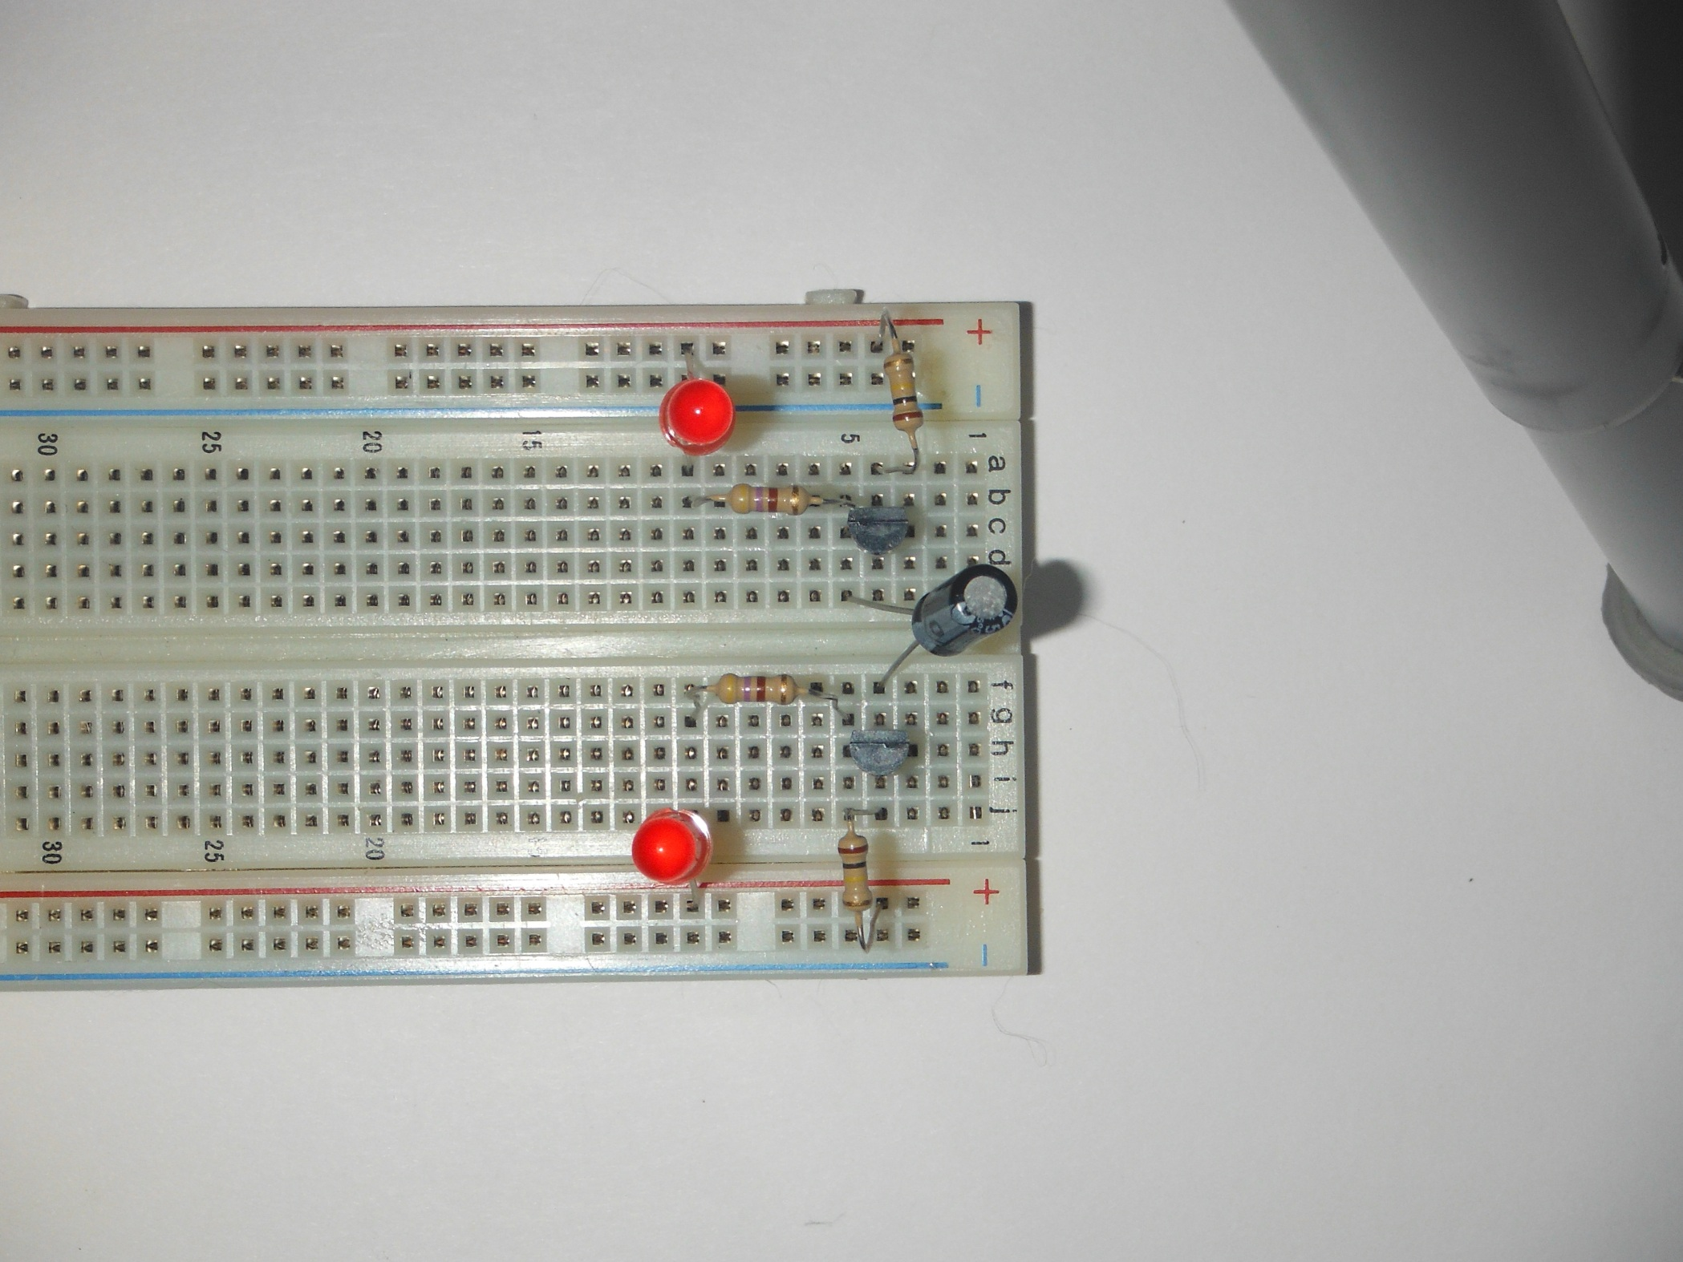

7) Insert Capacitor, Short Leg at upper transistor Base (B) Column 4, Long Leg as lower transistor Collector (C) Column 5. Adjust capacitors so that legs do not touch.  
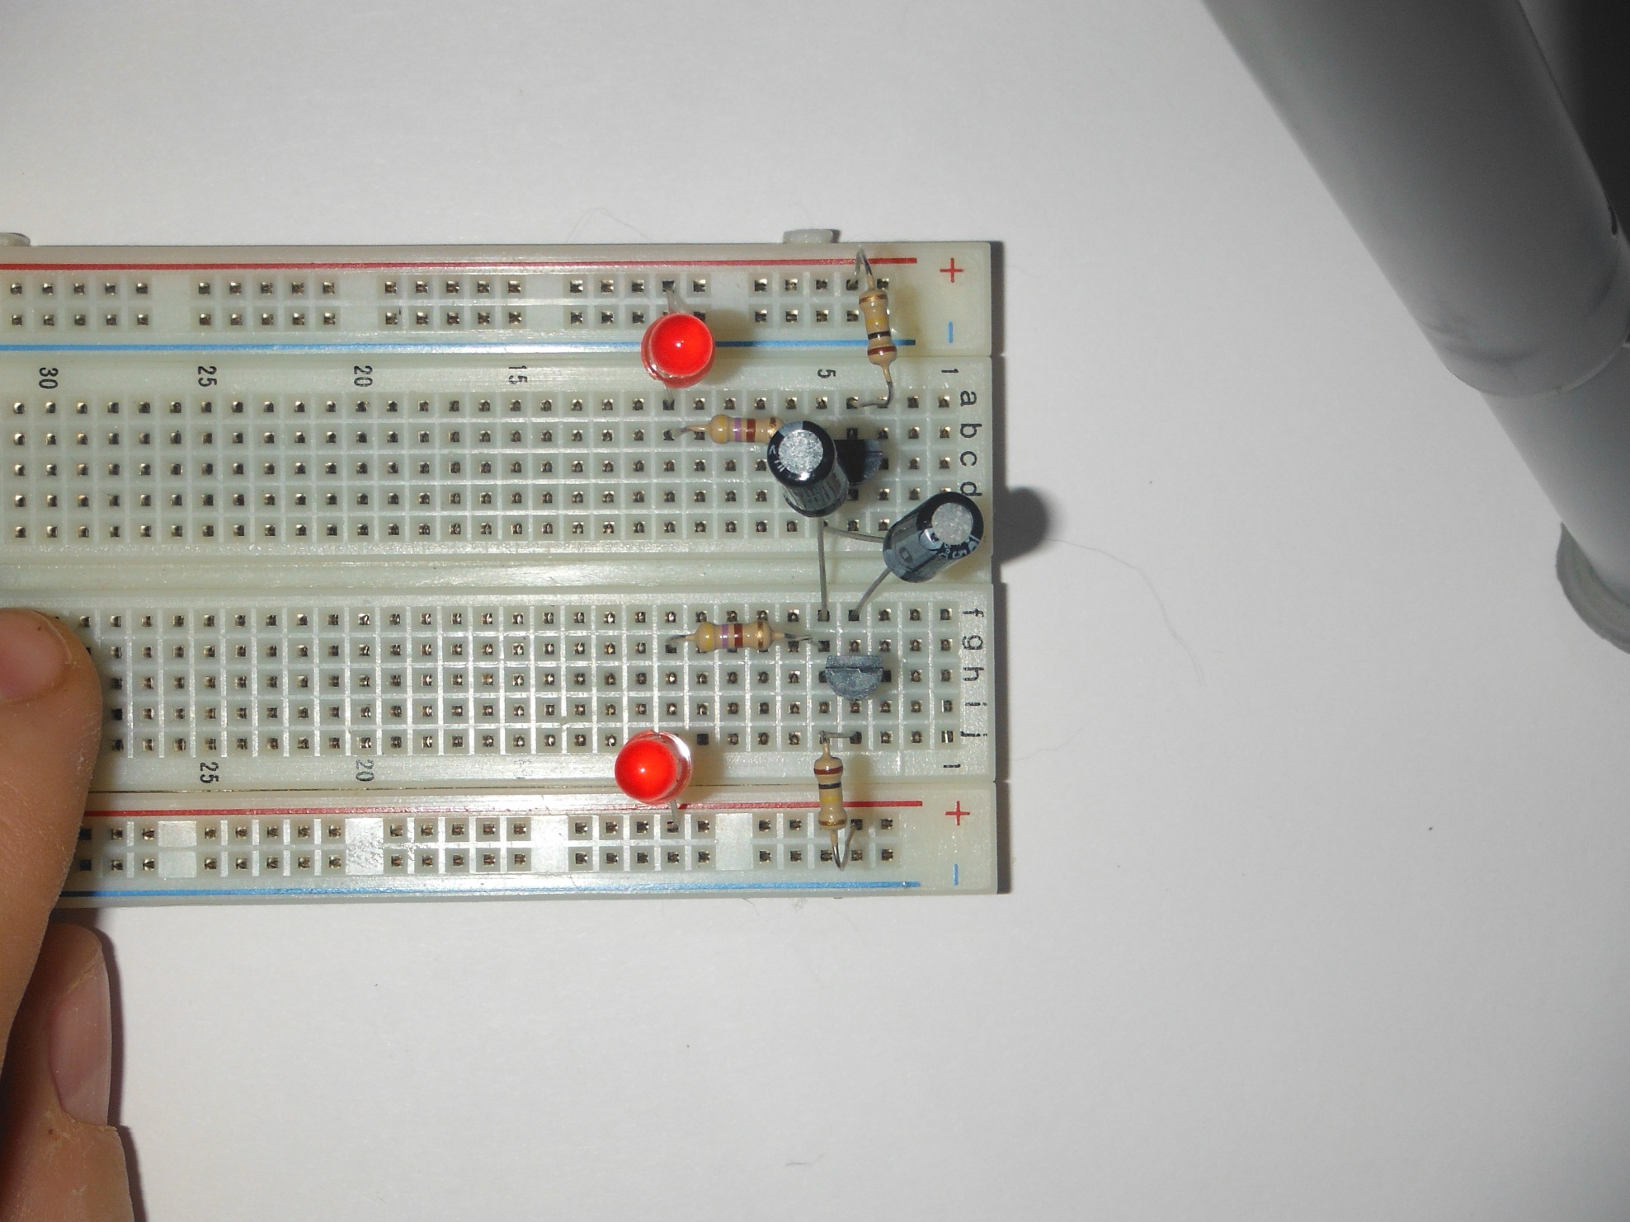  
  
8) Tie Positive Rails together.  
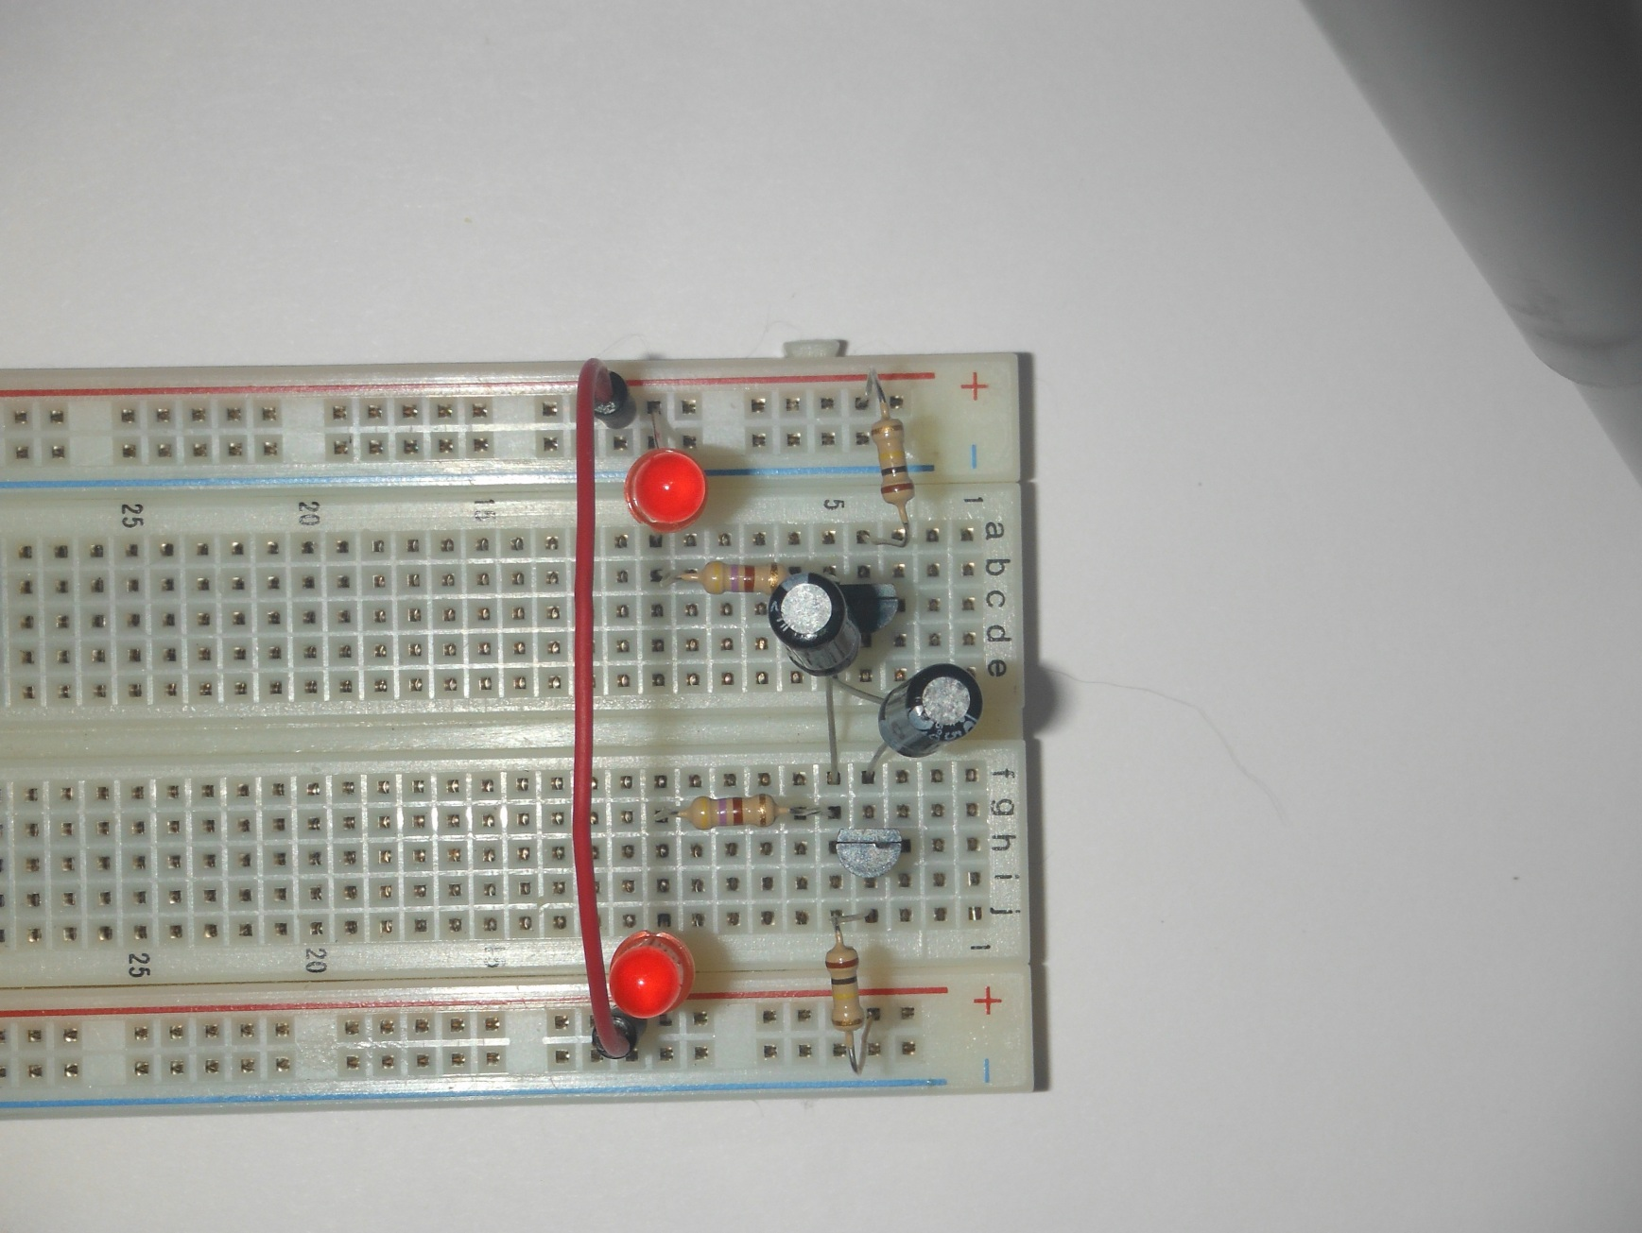

9) Jumper top transistor emitter (E) column 3, to bottom transistor emitter (E) column 3.  
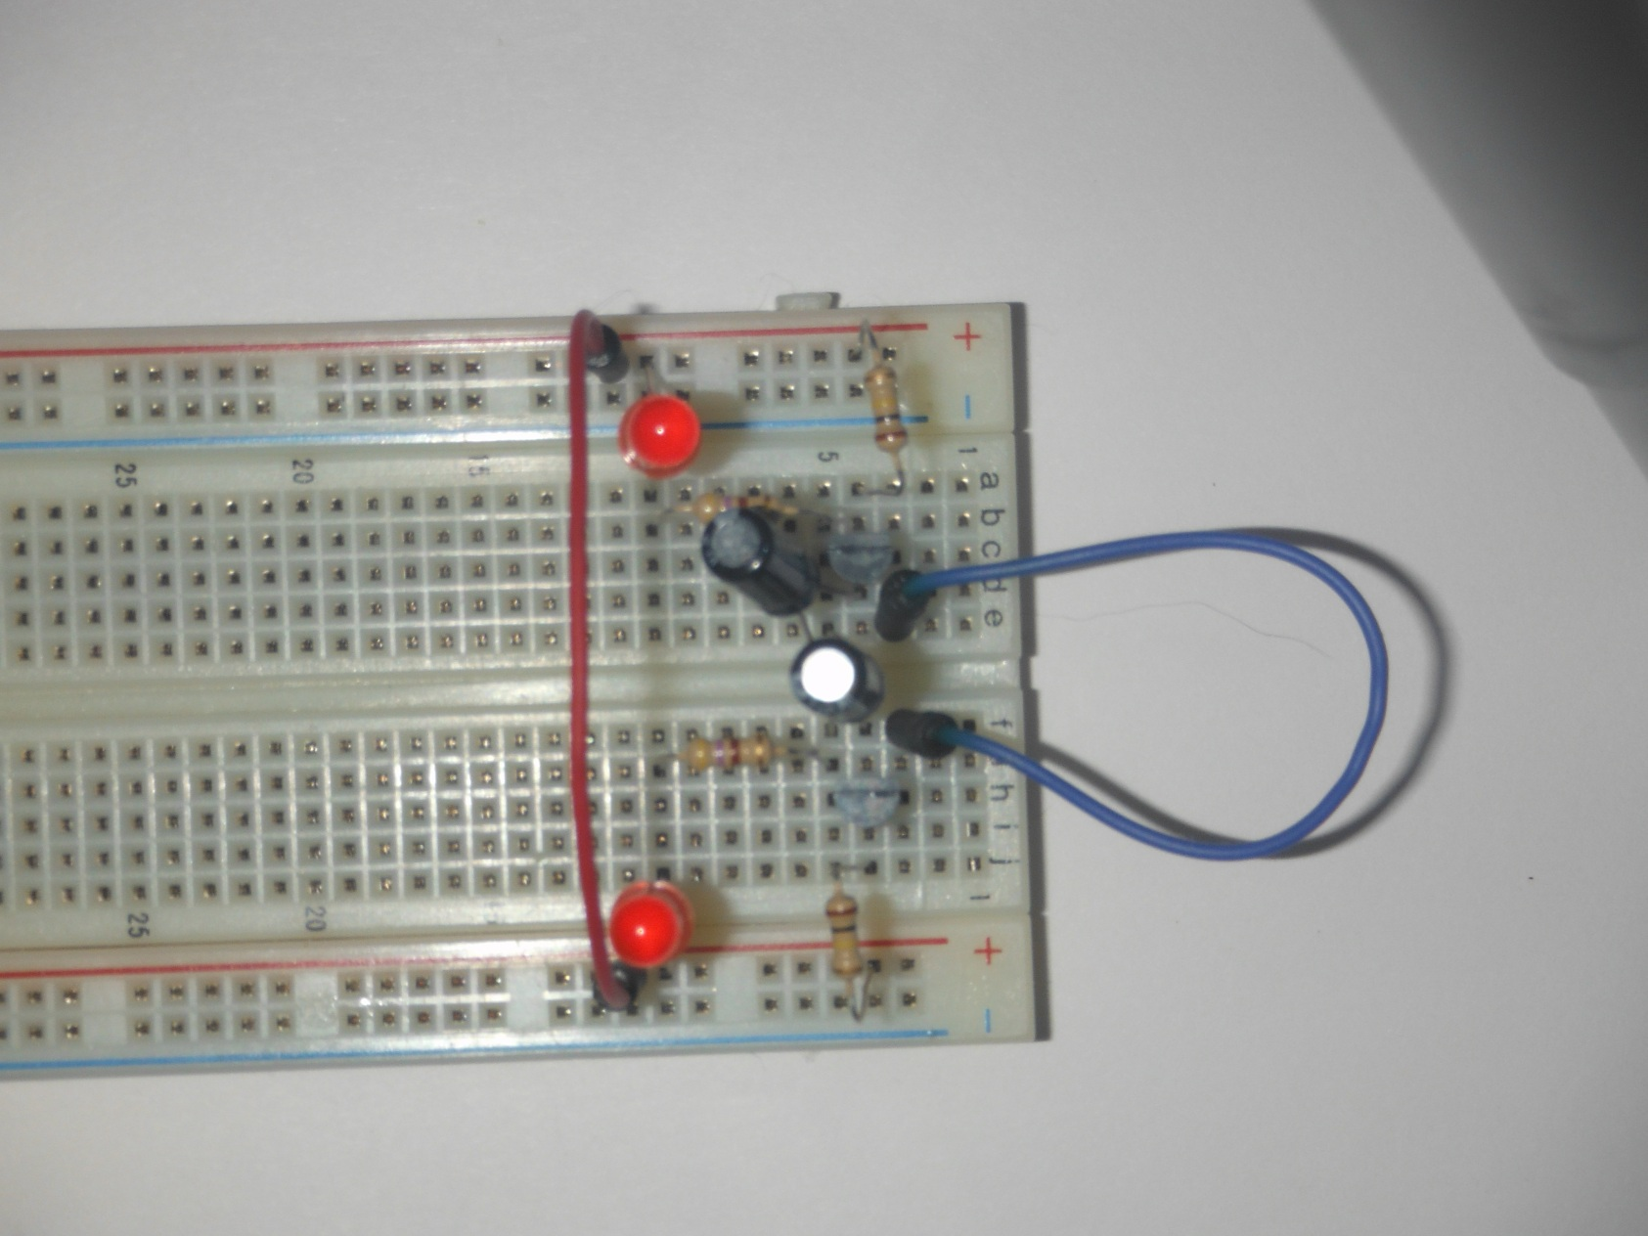

9) Jumper bottom transistor emitter (E) column 3, to bottom Ground Rail.  
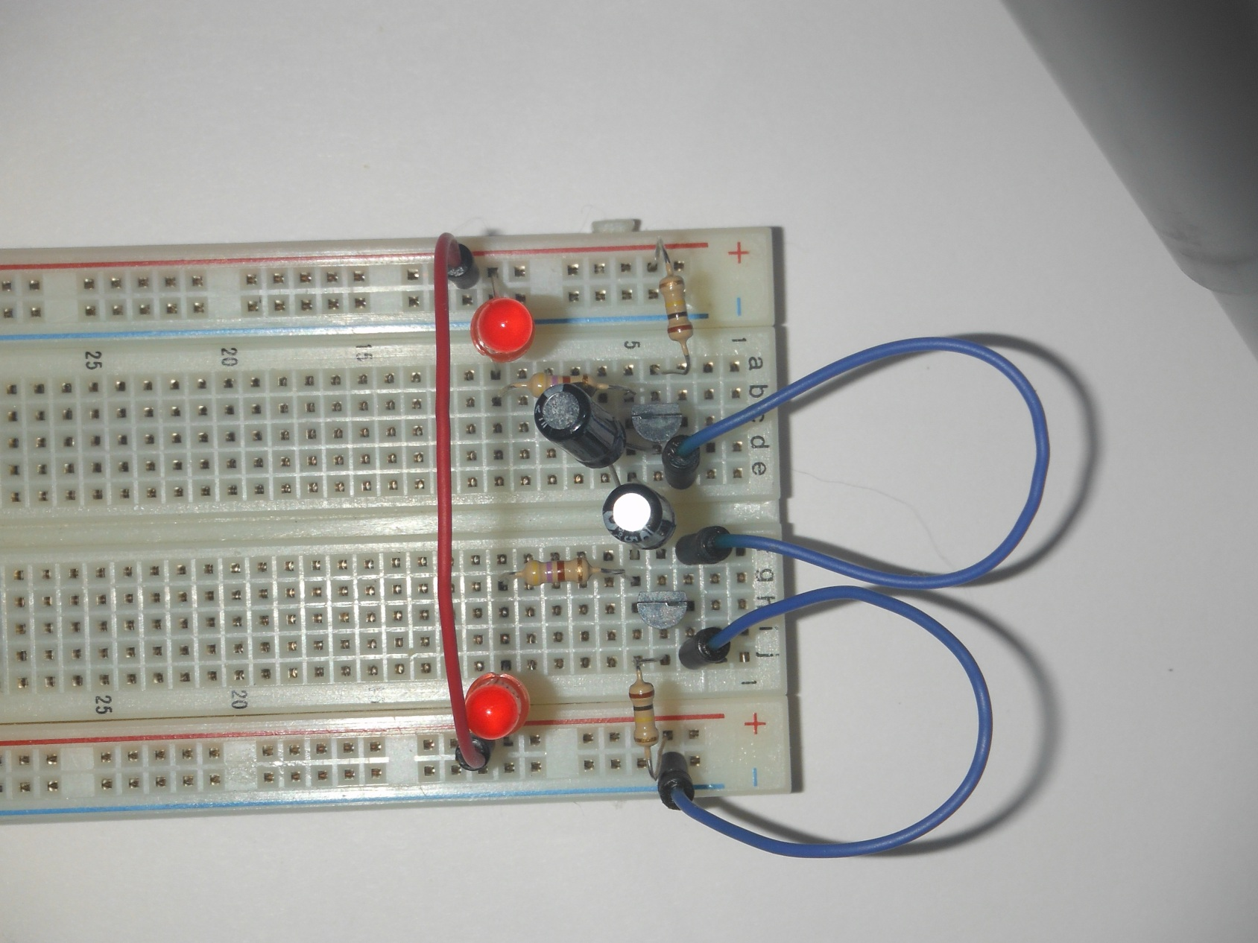  
  
10 Attach Battery, Ground to bottom Ground Rail, Positive to Positive Rail.  
Light Emitting Diodes, LEDs will immediately start blinking.  




